

CO4 ASSESSMENT TOOL 2 – CI/CD PIPELINE DESIGN EXERCISE

Department of Computer Science and Engineering

Project: SmartCare Assets — Intelligent Hospital Asset Tracking
and Equipment Management Platform

Field | Details
Course Code | CSA10 / CSA1063
Course Title | Software Engineering
CO Assessed | CO4 – Implement robust testing, quality assurance, and DevOps practices, emphasizing security, reliability, and ethics
Assessment | Assessment Tool 2 – CI/CD Pipeline Design Exercise
Student Name | Ashwin S
Register No. | 192311410

1. Requirement & Pipeline Analysis

1.1 Assigned Problem Statement (Recap)
SmartCare Assets is a FastAPI/PostgreSQL backend for a hospital asset-tracking platform. It exposes endpoints to register medical equipment, ingest battery/location telemetry, and flag maintenance-required assets, and is packaged with Docker and Docker Compose. Because this service will eventually run in a live hospital environment, code changes must reach production only after passing automated checks — manual, ad-hoc deployment is not acceptable for a system that affects patient-care equipment visibility.

1.2 CI/CD Needs Identified
- Every push must be automatically linted and tested before it can be merged or deployed, so defects are caught before they reach staging or production.
- Security must be checked continuously (source code and dependencies), not only at release time, given the sensitivity of a hospital-adjacent system.
- The Docker image already defined for this project (Section 8 of the companion Git & Docker assignment) needs to be built, scanned, and published automatically rather than built by hand on a developer's machine.
- Staging must reflect develop automatically so testers always have a current build to validate against.
- Production deployment must never happen without an explicit human approval step, given the operational stakes, and must be reversible quickly if a deployment misbehaves.
- The team (or future team members) needs visibility into pipeline outcomes without manually checking a dashboard — automated notifications are required.

1.3 Constraints From the Existing Project
The pipeline design must build on artifacts that already exist in the repository rather than invent a parallel process: the Git Flow branching model (main / develop / feature / release / hotfix) established previously, the existing Dockerfile and docker-compose.yml, and the existing Pytest suite and flake8 configuration used during the code review. The CI/CD pipeline in this document is therefore designed as the automation layer that sits on top of those existing practices, not a replacement for them.

2. Pipeline Architecture and Workflow
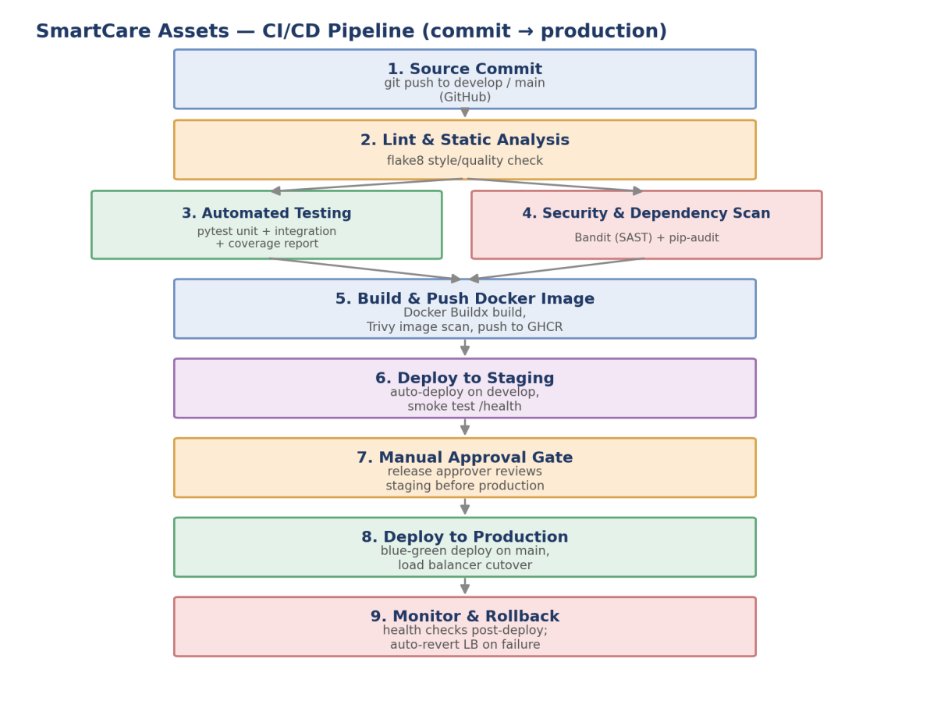
Figure 1: SmartCare Assets CI/CD pipeline — source commit to production deployment

2.1 Stage-by-Stage Workflow
1. Source Commit: a developer pushes to develop (ongoing work) or opens a pull request into main (release). GitHub Actions triggers the pipeline automatically on both push and pull_request events.
2. Lint & Static Analysis: flake8 runs against app/ first, since a syntactically or stylistically broken commit should fail fast before the slower test and security jobs run.
3. Automated Testing (parallel with Stage 4): the Pytest suite — including the integration tests added during the code review — runs with coverage measurement, failing the build if coverage drops below a configured threshold.
4. Security & Dependency Scan (parallel with Stage 3): Bandit performs static application security testing (SAST) on the Python source, and pip-audit checks requirements.txt for known CVEs in dependencies. Running this in parallel with testing, rather than after it, keeps overall pipeline time down.
5. Build & Push Docker Image: only runs once both testing and security scanning succeed. The image is built with Docker Buildx, scanned again as a built artifact with Trivy (catching OS-package vulnerabilities that source-level scanning cannot see), and pushed to a container registry tagged with both the commit SHA and latest.
6. Deploy to Staging: triggered automatically whenever the pipeline succeeds on develop. The staging Compose overlay pulls the freshly published image and a smoke test confirms /health responds before the job is marked successful.
7. Manual Approval Gate: when a change reaches main (via a reviewed pull request from develop or a hotfix branch), the pipeline pauses and waits for a designated release approver to authorize production deployment — this is the human checkpoint required for a hospital-facing system.
8. Deploy to Production: uses a blue-green strategy — the new image is deployed as api-green alongside the currently running api-blue, smoke-tested, and only then does the load balancer redirect traffic to it.
9. Monitor & Rollback: post-deployment health checks continue to watch the new version; if they fail, the pipeline automatically reverts the load balancer target back to api-blue without waiting for manual intervention.

3. Tools and Technology Selection
Pipeline Stage | Tool(s) Selected | Justification
Source Control & Trigger | GitHub + GitHub Actions | The repository already lives on GitHub (per the Git & Docker assignment); Actions requires no separate CI server to install or maintain, and integrates natively with pull requests, environments, and secrets.
Lint / Static Analysis | flake8 | Already used during the manual code review (Assessment Tool 2 for CO3); reusing it in CI turns a one-time manual check into a continuously enforced gate.
Automated Testing | Pytest + pytest-asyncio + pytest-cov | Matches the existing async FastAPI test suite exactly; pytest-cov adds a coverage gate with no change to how tests are written.
SAST (source security) | Bandit | Purpose-built for Python; scans for common insecure patterns (e.g., hard-coded secrets, unsafe deserialization) directly in the source tree with no external service required.
Dependency Scanning | pip-audit | Cross-references requirements.txt against known CVE databases; catches vulnerable third-party packages that source-level SAST cannot see.
Container Build | Docker Buildx | Builds the existing Dockerfile unchanged; Buildx's layer caching keeps CI build times low, consistent with the layer-ordering already used in the Dockerfile.
Container Image Scanning | Trivy | Scans the built image for OS-package and library vulnerabilities after build — a different (and necessary) layer of security coverage than source-level Bandit/pip-audit scanning.
Container Registry | GitHub Container Registry (GHCR) | Co-located with the existing GitHub repository and Actions workflow, avoiding a third-party account/credential to manage separately.
Deployment Orchestration | Docker Compose overlays (staging/prod) | Extends the docker-compose.yml already designed for local development, rather than introducing an entirely new deployment technology for a service of this size.
Notifications | Slack webhook + email (on-call) | Slack gives the team immediate visibility into pipeline results; email ensures the on-call engineer is reachable even outside Slack for production-affecting failures.

4. Automated Testing Strategy

4.1 Testing Layers Integrated Into the Pipeline
Unit and integration tests (Pytest): the five tests established during the code review — covering asset registration, duplicate tracking-ID rejection, telemetry-driven low-battery alerts, and the health-check endpoint — run on every push, using an in-memory SQLite override so the test job needs no external database service.
Coverage gate: pytest-cov enforces a minimum coverage threshold (--cov-fail-under=70); a pull request that drops coverage below this line fails the pipeline rather than merely producing a warning.
Static analysis as a testing layer: flake8 is treated as a first-class, blocking test stage rather than an optional style check, since it runs before (and gates) the test and security jobs.
Security testing: Bandit and pip-audit function as automated security tests — the pipeline fails the build on medium/high-severity findings rather than merely reporting them.
Post-deployment smoke tests: after both staging and production deployment, an automated call to GET /health confirms the newly deployed container is actually serving traffic before the job is marked successful.

4.2 What Is Deliberately Left Out of This Pipeline (and Why)
Full end-to-end UI testing is not included, since SmartCare Assets is currently a backend-only service with no frontend in this repository; this would be added as a separate pipeline stage once a dashboard client exists. Load/performance testing is also left for a later stage of the project, once realistic hospital-scale telemetry volume can be estimated — introducing it prematurely would slow every pipeline run without yet reflecting real usage patterns.
5. Deployment Strategy, Security, and Rollback

5.1 Deployment Environments
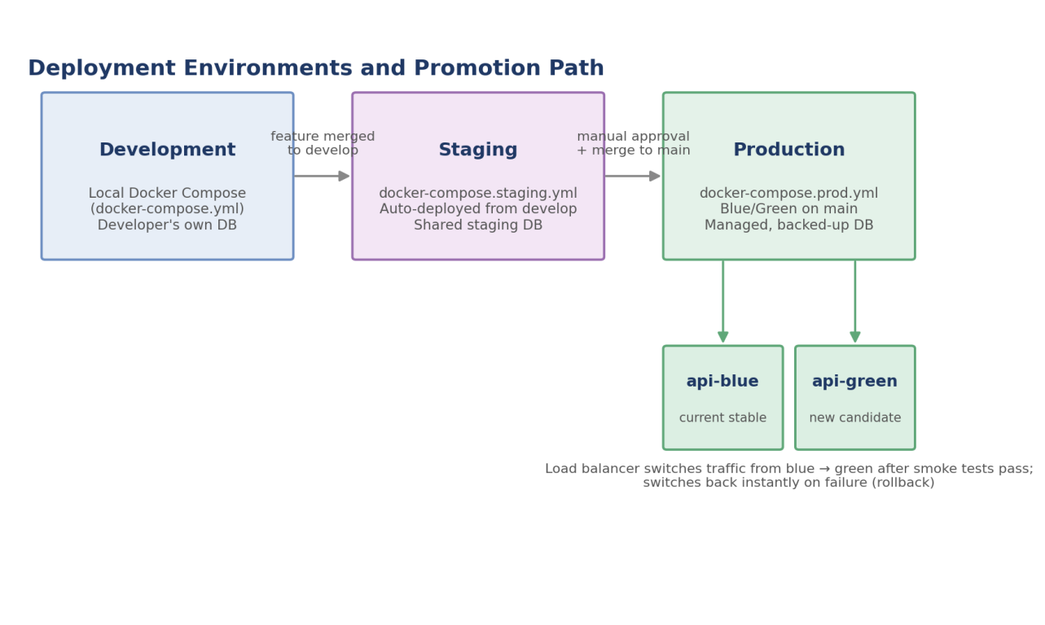
Figure 2: Deployment environments and promotion path
Development: runs locally via the existing docker-compose.yml, using a developer's own disposable database — no pipeline involvement, fastest feedback loop.
Staging: docker-compose.staging.yml, auto-deployed by the pipeline on every successful push to develop, against a shared staging database so testers see a consistent, current build.
Production: docker-compose.prod.yml, deployed only from main and only after manual approval, using a blue-green pair (api-blue / api-green) so the previous version keeps running until the new one is verified.

5.2 Security Practices Incorporated
- Static application security testing (Bandit) and dependency vulnerability scanning (pip-audit) run on every push, not just before release.
- Built container images are scanned with Trivy before being pushed to the registry; the pipeline fails the build on critical/high-severity findings rather than shipping a vulnerable image.
- Credentials (registry login, database URLs) are stored as GitHub Actions secrets/environment variables, never committed to the repository — consistent with the .env-based configuration approach already used in docker-compose.yml.
- Production deployment requires a named environment (production-approval) with a manual reviewer, preventing any single compromised or mistaken push from reaching hospital-facing infrastructure unattended.

5.3 Rollback Mechanism
Because production uses a blue-green pair, rollback does not require rebuilding or redeploying anything: if post-deployment health checks on api-green fail, the pipeline's failure step immediately points the load balancer back at api-blue, which was never stopped. This makes rollback a load-balancer configuration change rather than a redeployment, reducing recovery time from a failed release to seconds rather than the minutes a fresh deployment would take.

5.4 Notifications
Every deploy-staging and deploy-production job posts its outcome (success or failure) to a Slack channel dedicated to this project, and production failures additionally trigger an email to the on-call engineer, ensuring a human is aware of a failed release immediately rather than discovering it later through a support ticket.
6. Pipeline Configuration

6.1 GitHub Actions Workflow (excerpt)
The full workflow file is committed at .github/workflows/ci-cd.yml. Its job dependency structure is summarized below, followed by the staging deployment job as a representative excerpt:
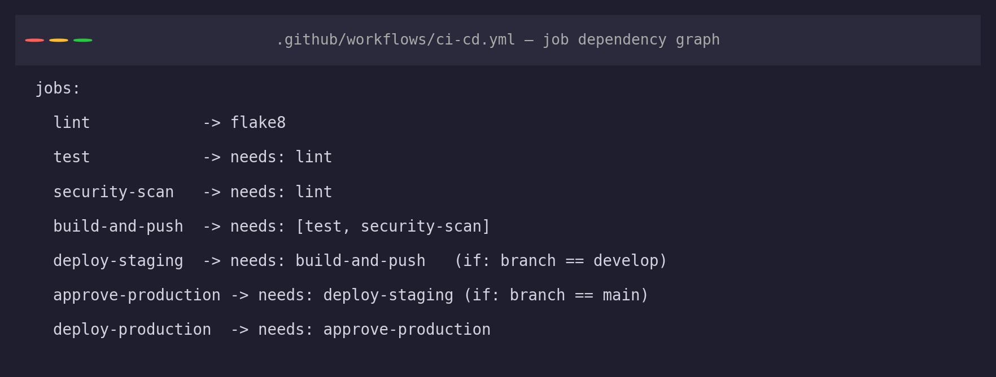
Figure 3: Job dependency graph declared in ci-cd.yml
deploy-staging:
name: Deploy to Staging
runs-on: ubuntu-latest
needs: build-and-push
if: github.ref == 'refs/heads/develop'
environment:
name: staging
url: https://staging.smartcare-assets.hospital.internal
steps:
- uses: actions/checkout@v4
- name: Deploy via SSH to staging host
run: |
docker compose -f docker-compose.staging.yml pull
docker compose -f docker-compose.staging.yml up -d
- name: Run smoke test against /health
run: curl --fail https://staging.smartcare-assets.hospital.internal/health
- name: Notify team (Slack)
if: always()
run: echo "Posting deployment status to #smartcare-deploys"

6.2 Version Control Evidence
The pipeline definition and its supporting environment overlay files were developed on a dedicated feature branch and merged into develop following the same Git Flow model used throughout this project, keeping the pipeline's own introduction auditable in the commit history:
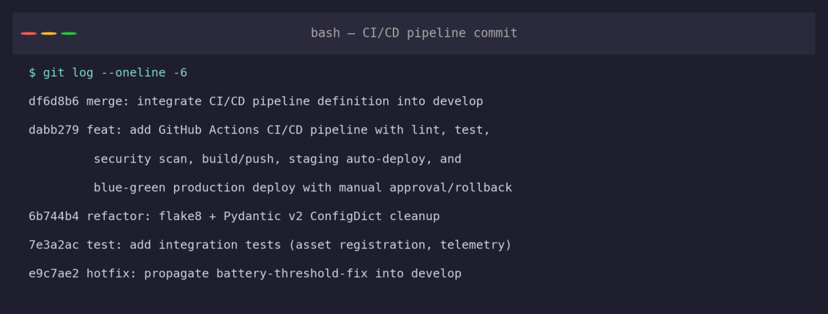
Figure 4: Commit history showing the CI/CD pipeline being added and merged
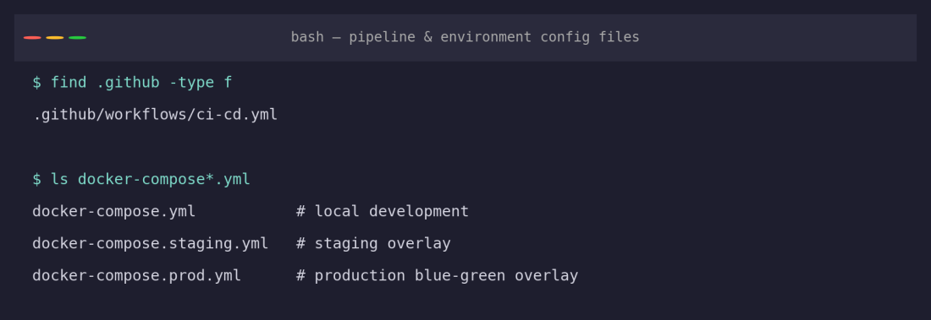
Figure 5: Pipeline and environment configuration files added to the repository

